Name: Dave Ng’ang’a

Box 557

Cairn University School of Business

CIS122 Essentials of Networking

Project 3

Project objective:

1) Set up a media server (FTP, RMTP, or similar)

2) Manage switch configurations to observe the results

3) Look at Wireshark, tcpdump

Equipment used:

|  |  |  |  |  |
| --- | --- | --- | --- | --- |
| Equipment Description | Vendor | Vendor Item # | Retail price | Actual price (if known) |
| Rasberry pi two | Allied Technology & Automation | 71032282 | 29.44 | Unknown |

Detailed list of software and operating platforms used, including version numbers and licensing requirements:

Raspberry PI OS and Terminal

Remote Desktop (windows)

Network diagram

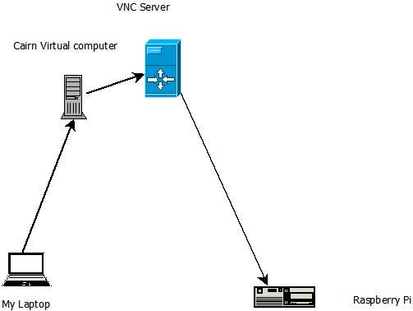

Configurations:

1. Set up Raspberry pi with a specific address
2. Through the virtual desktop access the VNC server in order to remotely connect to the raspberry pi
3. After successful log in – Access the terminal and install Tcpdump
   * Sudo apt install tcpdump
     + sudo means super user and allows administrative privilege.
     + Apt – stands for advanced packaging tool and is a package manager.
     + Install – installs the package specified in this case tcpdumb
4. You can use the command Sudo tcpdump –I eth0 –e –XX to print out the incoming packet
   * Be sure to verify the data coming through
     + Check to be sure the mac address is the right one for the raspberry pi